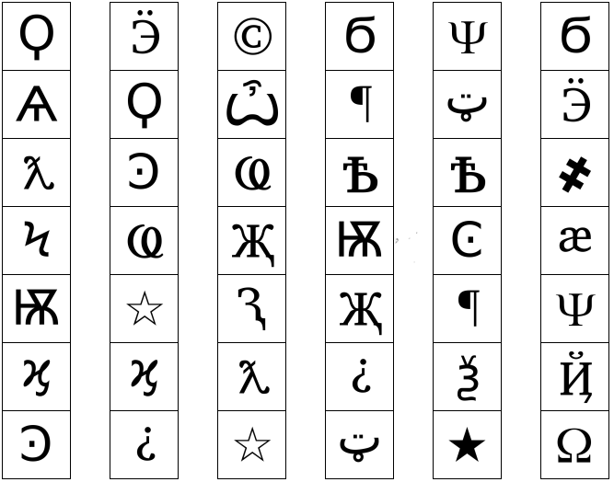On the Subject of Keypads

27

26

20

25

24

8

16

23

22

17

21

18

19

20

19

11

14

18

17

16

10

15

14

13

12

111

10

5

3

9

6

9

7

1

8

3

4

5

6

7

2

1